Energy Burden Analysis Over Time Series for Counties in Arizona

Nancy Rankin
Mesa Community College
CIS480 Data Analytics and Programming Capstone
Dr. Kazuaki Kashihara
May 3, 2026

Chapter 1: Energy Burden Analysis Over Time Series for Counties in Arizona

Introduction
This project will be exploring energy burden over a time series for counties in Arizona. Initially, the focus will be on residential consumers, however comparisons to other sectors’ energy use may help shed light on increasing energy costs.
Initially, energy was just a topic on a suggested list of subjects. It piqued my interest because after a recent move to a small place, I noticed the same if not higher energy bills in the summer, which did not make sense to me. I think that if I could review the affordability of household electric over the last decade and a half, I could understand why energy costs only seem to increase.
In real world data analytics, this topic would be part of a broader project. It might be for an economist comparing changes in utilizes over time, or it could be for an energy company looking for market trends to be more competitive. The application of this project most likely would not be a stand-alone ad hoc report as the context would need specific conditions to be necessary.

Objective
The objective of this project will be to use the energy burden formula, (electricity costs / income), over different years to see how affordable energy is for counties in Arizona.
Questions
- What is the energy burden in different counties in Arizona?
- How has the energy burden changed over the last 15 years?
- What is the percentage of total use was residential over the last 15 years?
- Should energy burden be compared by county?
- How has income changed over the last 15 years?
- If possible, can buying power be determined and assessed to give energy burden context?

Scope and Sources
The years of study in this project will be 2024, 2020, 2018, 2015, 2010 mostly based on consistency of data availability. All counties in Arizona will be included. However, this may need to be narrowed based on data availability. Residential household income and energy usage will be the main focus of this project, with minor attention given to comparing other sectors of energy usage.
Policy Map will be used to gather the median family income based on county subdivisions for the state of Arizona. During the exploratory phase of data analysis, other data points may be considered from Policy Map such as unemployment rate and percent of households with access to electricity. Additionally, a map of electric districts from APS may be used to compare energy burden across different counties and districts. Due to the districts not being consistent with county lines, this comparison may not be feasible.
The monthly form EIA-861M will be used as the primary dataset for energy consumption by county and sector. Using this dataset will allow me to calculate the percentage of electricity use that was residential, which answers one of the project questions.
Two datasets from the United States Census Bureau defining financial characteristics for housing units with and without mortgages will give a more detailed analysis of energy burden per household as it is split by county.
Additionally, from the U.S. Bureau of Labor Statistics, the consumer price index supplemental files for all urban consumers for the given year will be pulled in so we can compare the average national electric cost versus the Arizona data.
The variables used will be price per kilowatt, customer count, sale by megawatt and revenue in thousands of dollars. Additional variables will include median family income, household income in the past 12 months group in ranges, and monthly housing costs in dollars and as a percentage. I will need to determine how to incorporate the different electric districts into this project because currently the visual map does not give a way to breakdown or tell how the districts are determined. Within the consumer price index workbooks, there is a variable for percentage change year over year for electricity that can be used to determine the increase nation-wide in urban areas versus Arizona specifically.

Feasibility and Next steps
The feasibility of this entire project is moderate given the question of buying power in relation to energy burden. The data sets listed above should provide enough information to answer all the questions for this project. The question of buying power will need to be determined from the consumer price indexes for the given years which should be feasible but will add a level of complexity to the project that will require more time.
The next steps will be to pull in the current data sets one by one and perform exploratory data analysis on them to determine if they will be sufficient to answer the project questions. Additionally, the monthly consumer price index reports will need to be concatenated to serve the purpose of this report.

Chapter 2: Hypothesis and Literature Review

Literature Review
Energy affordability has become an increasing concern across the United States as electricity prices, housing costs, and economic inequality continue to rise. Energy burden is commonly defined as the percentage of household income spent on energy OS. Households with higher energy burden often experience financial stress and may struggle to meet other essential needs such as housing, food, and health care. Understanding how energy burden changes over time and across geographic areas is important for policymakers from utility providers, and researchers seeking to address economic inequality and energy accessibility.
Previous research indicates that energy burden varies significantly across income groups and geographic regions. Drupal and Ross (Drehobl & Ross, 2016) found that low-income households in the United States often experience energy burdens up to three times higher than those of higher income households. This disparity occurs because energy consumption levels do not always decrease proportionally with income. As a result, lower-income households may spend a much larger percentage of their income on utilities even when their total energy consumption is similar to that of a higher-income household.
Housing conditions and climate can also influence household energy costs. Homes with poor insulation or inefficient cooling systems often require higher electricity consumption to maintain comfortable indoor temperatures. In regions with extreme temperatures, such as Arizona, cooling demands during summer months may significantly increase residential electricity usage. These environments and structural factors can contribute to variations in energy burden across households and geographic areas.
Electricity prices have also fluctuated over time due to changes in fuel costs, infrastructure investments, and regulatory policies. Data from the US Energy Information Administration (EIA) indicate that electricity prices have generally increased over the past two decades, although the rate of increase varies across States and utility providers. In rapidly growing states such as Arizona, the population growth and rising energy demand may place additional pressure on electricity infrastructure, potentially contributing to higher costs.
Income trends also play a significant role in determining energy affordability. Median household income is commonly used as an indicator of economic stability. When electricity costs increase faster than income growth, households may experience increasing financial pressure. Hernández (Hernández, 2016) explains that energy and security often emerge when rising utility costs intersect with stagnant wages and increasing housing expenses. This dynamic can force households to make difficult trade-offs between paying for energy and meeting other basic needs
Geographic variation is another key factor affecting energy burden. County level economic differences can lead to variations in both electricity consumption patterns and income levels. Areas with higher wages or stronger economic growth may experience lower energy burdens, even if electricity prices are relatively high. Conversely, counties with lower income levels may experience greater financial strain from similar electricity costs.
Previous research also suggests that analyzing energy burden using a time series approach can reveal important trends and affordability. Longitudinal studies allow researchers to identify whether energy costs are rising faster than income and whether certain regions experience greater vulnerability to these changes. Such analysis can provide valuable insights for policymakers seeking to develop programs that reduce energy insecurity. Despite growing research on energy burden and energy insecurity relatively few studies focus specifically on county level energy burden trends within Arizona. Most existing research examines national or metropolitan trends rather than localized patterns within a single state. This gap in the literature creates an opportunity to explore how energy affordability varies within Arizona counties over time.
This capstone project builds on the initial research proposal, which identifies the goal of analyzing energy burden across Arizona counties using publicly available data sets. By combining electricity consumption data from the U.S. Energy Information Administration with household income data from the U.S. Census Bureau and consumer price index data from the Bureau of Labor statistics, this project aims to analyze how energy affordability has evolved over the past 15 years.
The findings of the study may contribute to a better understanding of regional differences in energy burden and help identify whether rising electricity costs are placing greater financial pressure on households in certain counties.

Hypothesis development
Based on existing research related to energy affordability, energy pricing trends, and household income variation, several hypotheses can be developed to guide the analysis in this project.

Hypothesis one

H₀ (Null Hypothesis):
There is no meaningful change in energy burden for Arizona counties between 2010 and 2024.

H₁ (Alternative Hypothesis):
Energy burden for Arizona counties has significantly increased between 2010 and 2024.

Test Type:
One tailed (directional)

Rationale:
Lower- income households typically spend a larger portion of their income on energy costs.

Hypothesis two

H₀ (Null Hypothesis):
There is no relationship between median household income and energy burden across Arizona counties.

H₁ (Alternative Hypothesis):
Counties with lower median household incomes experience higher energy burdens compared to counties with higher median household income.

Test Type:
One tailed (directional closed parentheses

Rationale:
Lower-income households typically spend a larger portion of their income on energy costs.

Hypothesis three

H₀ (Null Hypothesis):
Residential electricity usage as a percentage of total electricity consumption has not changed significantly over the study period.

H₁ (Alternative Hypothesis):
Residential electricity usage as a percentage of total electricity consumption has changed significantly over the study period.

Test Type:
Two-tailed (non-directional)

Rationale:
Population growth and residential development may alter the proportion of electricity used by residential consumers over time.

Hypothesis four

H₀ (Null Hypothesis):
There are no significant differences in energy burden between counties and Arizona.

H₁ (Alternative Hypothesis):
Energy burden differs significantly between counties and Arizona.

Test Type:
Two-tailed (non-directional)

Rationale:
Economic conditions, population density, and climate differences across counties may lead to variations in electricity consumption and household income levels.

Chapter 3: Data Collection and Modeling Strategy

Data Collection Strategy
This study examines how energy burden Varies across Arizona counties overtime and identifies the key economic and energy related factors contributing to these differences. The data collection strategy was designed to integrate multiple publicly available datasets into a unified analytical framework that supports both statistical modeling and dashboard-based visualizations.

Data Sources
Data for this project was collected from the U.S. Census Bureau, the U.S. Energy Information Administration (EIA), and the Arizona public service (APS). The you. S. Census Bureau provided demographic and economic variables, including median household income and housing-related cost measures (U.S. Census Bureau, 2010, 2024). The EIA data set supplied utility level data, including total revenues, electricity sales (megawatt-hours), and customer counts (U.S. Energy Information Administration, n.d.). APS service area maps were used to support the geographic alignment of utility data to counties, ensuring accurate representation of service coverage (Arizona Public Service, n.d.).
These sources were selected due to their credibility, consistency, and relevance to the research objectives. Federal data sources such as the Census Bureau and EIA provide standardized methodologies and are widely used in academic and policy research. APS service maps supplement these datasets by providing geographic context necessary for accurate data integration.

Geographic And Temporal Scope
The unit of analysis for this study is the county level within the state of Arizona. Counties were selected as the primary geographic unit because they provide a consistent boundary across datasets while maintaining sufficient granularity to identify regional variations.
The temporal scope includes five key years: 2010, 2015, 2018, 2020, and 2024. These years were selected based on data availability and their ability to capture long-term trends. Due to structural differences in housing-related variables between earlier and later data sets, the analysis was divided into two periods: 2010-2015 and 2018-2024. This separation ensures comparability of variables within each modeling group.

Data Types and Variables
The data set includes continuous and derived variables representing economic, demographic, and energy-related characteristics. Core variables include median household income, population, total utility revenue, electricity sales, and customer counts.
Several derived variables were created to better capture energy burden dynamics. These include average energy cost per customer, calculated as total utility revenue divided by the number of customers; electricity usage per customer, derived from total electricity sales; and price per kilowatt-hour, calculated using revenue and sales data. The dependent variable, energy burden, was defined as the ratio of average annual energy cost to median household income.
Housing cost burden variables were standardized into three categories: household spending less than 30%, between 30 and 50%, and greater than 50% of income on housing for the 2010-2015 dataset. Because data collection changed between 2015 and 2018, housing cost burden variables were standardized into three categories: housing spending less than 20%, between 20 and 29%, and greater than 30% of income on housing for the 2018-2024 data set.
These variables were selected to align directly with the research questions and to support both regression modeling and dashboard visualization.

Data Cleaning and Integration
Data preparation required extensive cleaning and transformation due to the inconsistencies across sources. Many datasets were initially provided in wide format with complex column naming conventions, requiring normalization into structured formats using Python (pandas).
Columns representing margins of error and percentage distribution were removed to maintain consistency across time periods. String cleaning was performed to standardize county names and ensure accurate merging across datasets.
A county-utility mapping reference file was created to align EIA utility-level data with county-level census data. APS service area maps were used to validate and refine this mapping process (Arizona Public Service, n.d.). Because utilities often serve multiple counties, allocation methods were applied to distribute values appropriately across geographic regions.
Separate preprocessing pipelines were developed for each time period ( 2010-2015 and 2018-2024) To address structural differences in the data. Cleaned data sets were exported for use in both statistical modeling and Power BI visualizations.
Care was taken to ensure that data transformations did not misrepresent underlying patterns, particularly when aggregating across geographic regions. All preprocessing steps were documented to support transparency and reproducibility.

Modeling Strategy

Model Type
The primary analytical method used in the study is multiple linear regression. This approach was selected because the dependent variable, energy burden, is continuous and represents a proportional relationship between energy costs and income.
Separate regression models were developed for each time period to maintain consistency in variable definitions and improve model validity.

Justification For Model Selection
Linear regression was chosen for its interpretability and alignment with the project's objectives. The goal of this analysis is not only to estimate energy burden but also to understand the relative influence of contributing factors.
While more complex machine learning models were considered, they were not prioritized due to the relatively small dataset and the need for clear, explainable results. Regression coefficients provide direct insight into the direction magnitude of relationships between variables, making the findings accessible to both technical and non-technical audiences.

Independent Variables and Features
Independent variables include median household income, average energy cost per customer, electricity usage per customer, and price per kilowatt-hour. Additional contextual variables, such as housing cost burden distributions and populations, were included to capture broader socioeconomic conditions.
Feature selection was guided by domain knowledge and exploratory analysis. Variables were chosen based on their theoretical relevance to energy burden and their ability to explain variation without introducing redundancy.

Model Evaluation and Interpretation
Model performance was evaluating using R-squared values to measure the proportion of variance explained by the model. Regression coefficients were analyzed to determine the direction and strength of relationships between independent variables and the energy burden.
The results of the regression analysis were designed to integrate directly with the Power BI dashboard, allowing users to explore trends and relationships visually. This approach supports effective communication and findings to both technical and non-technical audiences.
Care was taken to avoid overfitting and to present results responsibly without overstating predictive accuracy. The model is intended to identify patterns and relationships rather than to produce deterministic predictions.

Conclusion
The data collection and modeling strategy for this project was designed to balance analytical rigor with practical implementation. By integrating multiple high-quality data sources, applying structured data preparation techniques, and using interpretable modeling methods, this study provides a clear framework for analyzing energy burden across Arizona counties. These methods established the foundation for the analysis and visualization presented in subsequent chapters.

Chapter 4: Dashboard Design and Visualization Analysis

Introduction
This chapter presents the design and implementation of a Microsoft Power BI dashboard developed to analyze energy burden across counties in Arizona over time. The purpose of this dashboard is to communicate relationships between median income, energy burden, energy usage, and price trends through an integrated and interactive visual system. Rather than serving as a collection of isolated charts, the dashboard is structured to guide users through logical analytical progression, supporting the evaluation of research questions and hypotheses introduced in earlier chapters.
The dashboard is organized into five primary report pages: Executive Overview, Energy Usage Trends, Year-Over-Year Change Analysis, Energy Burdened by County, and Modeling/Risk Factors. Each page is designed to address a specific analytical dimension while maintaining consistency in layout, color usage, and interactivity. Together, these components create a cohesive analytical tool that enables both high-level insights and detailed exploration.

Executive Overview Dashboard
Figure 1
Executive Overview Dashboard
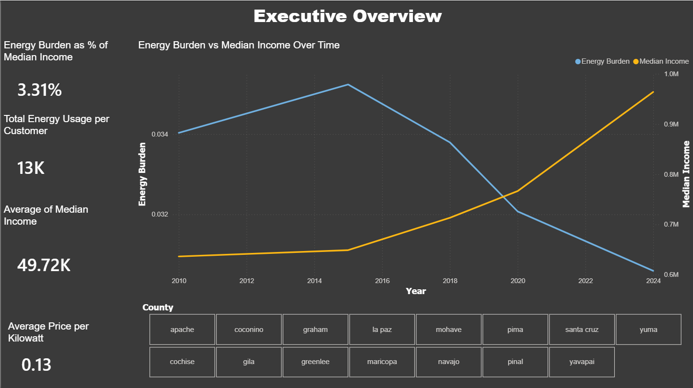

Note: This figure displays key performance indicators and a dual-axis line chart showing trends in a median income and energy burden over time.
The Executive Overview page provides a high-level summary of the data set through key performance indicators (KPIs) and a dual-axis trend visualization. This page addresses the research questions: How do income and energy burden change over time, and what is their relationship?
The associated hypotheses are:
- H₀ (Null Hypothesis): There is no relationship between median income and energy burden over time.
- H₁ (Alternative Hypothesis) : There is a relationship between median income and energy burden over time.
A dual-axis line chart was selected to simultaneously display median income and energy burden across time. This design choice is particularly effective because it allows two variables with different scales to be compared within a single visual space making trends and divergences immediately visible. Compared to separate charts, like bar or columns charts, this approach reduces ambiguity and highlights interactions effects between variables. Additionally, a county slicer was incorporated to enable users to explore detailed, county specific insights and answer more granular analytic questions, in contrast to a purely graphical approach, which did not provide sufficient clarity or level of detail for deeper analysis.
The visualization is structured with:
- X-axis: Year
- Primary Y-axis: Energy Burden (%)
- Secondary Y-axis: Median Income
- Legend: Energy Burden and Median Income
The inclusion of KPI cards (e.g., average energy burden, total energy usage per customer, average median income, price per kWh) provides immediate context and supports quick decision making. These KPI's are positioned on the left side of the dashboard to establish a visual entry point, guiding user attention before engaging with more complex visuals (line chart).
Analysis of this page reveals a diverging trend: median income increased steadily over time, while energy burden peaks around 2015 and then declines. This suggests that rising income may contribute to reducing energy burden, providing preliminary support for rejecting the null hypothesis.

Energy Usage Trends
Figure 2
Energy Usage Trends Dashboard
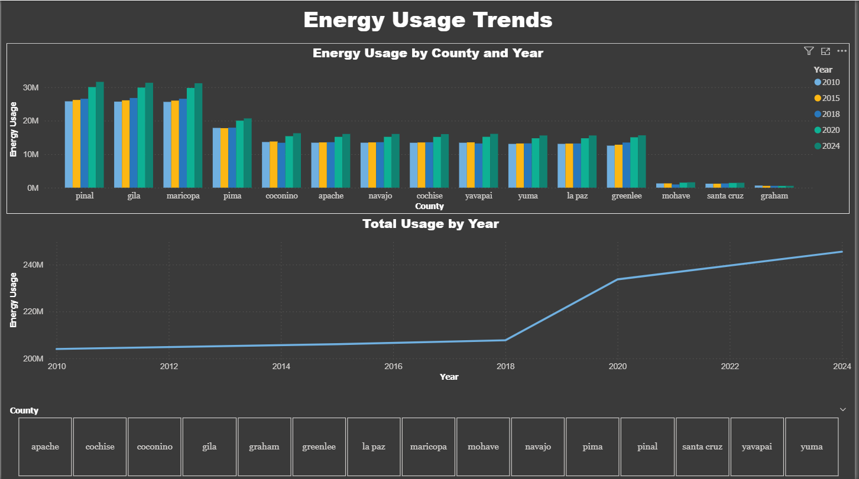
Note: This figure shows energy usage by country across the years and total energy consumption trends over time.
This page addresses the research question: how does energy usage vary across county overtime?
- H₀: Energy usage remains constant across counties and time.
- H₁: Energy usage varies across counties and time.
A clustered bar chart was selected to display energy usage by county and year. This visualization is appropriate because it allows for direct comparison across both categorical (county) and temporal (here) dimensions. Compared to stacked bar charts, the clustered format preserves individual values and avoids distortion of relative differences.
A county slicer was implemented to allow users to isolate specific regions and conduct more precise, focused analysis, addressing the limitations of a purely graphical approach that did not provide sufficient clarity or detail for deeper interpretation.
The visualization includes:
- X-axis: County
- Y-axis: Energy Usage
- Legend: Year
Additionally, a line chart showing total energy usage over time provides a macro-level trend. This combination of micro (county-level) and macro (state-level) views enhance analytical depths.
The data structure includes both categorical (county) and temporal (year) dimensions, which directly influence the use of multiple complementary visualizations.
Analysis indicates that energy usage increases over time across most counties, with particularly high usage in more populous regions such as Maricopa and Pinal counties. The total usage trend shows a notable increase after 2018, suggesting potential drivers such as population growth or increased energy demand.

Year Over Year Change Analysis
Figure 3
Year-Over-Year Change Dashboard
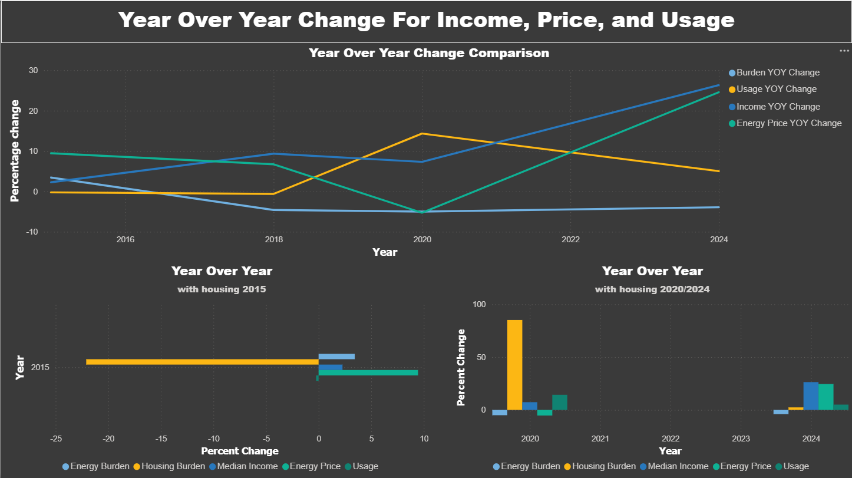
Note: This figure displays percentage changes in energy burden, income, usage, and energy prices over time.
This page addresses the question: How do changes in income, energy price, and usage impact energy burden over time?
- H₀: Changes in income, price, and usage do not affect energy burden.
- H₁: Changes in these variables influence energy burden.
A multi-line chart was selected to display year-over-year percentage changes. This chart type is appropriate because it emphasizes trends and directional changes across multiple variables simultaneously. Compared to separate charts, this design allows for immediate comparison of variable interactions.
This visualization includes:
- X-axis: Year
- Y-axis: Percentage Change
- Legend: Burden, Income, Usage, and Price Changes
Additional bar charts provide focused comparisons for specific periods (2015 and 2020/2024), improving interpretability of discrete changes.
Analysis shows that income growth generally trends upward, while energy burden fluctuations appear inversely related to income changes, particularly in later years. Energy price changes also exhibit a strong upward trend after 2020, suggesting a contributing factor to energy burden variability.

Energy Burdened by County
Figure 4
Energy Burden by County Dashboard
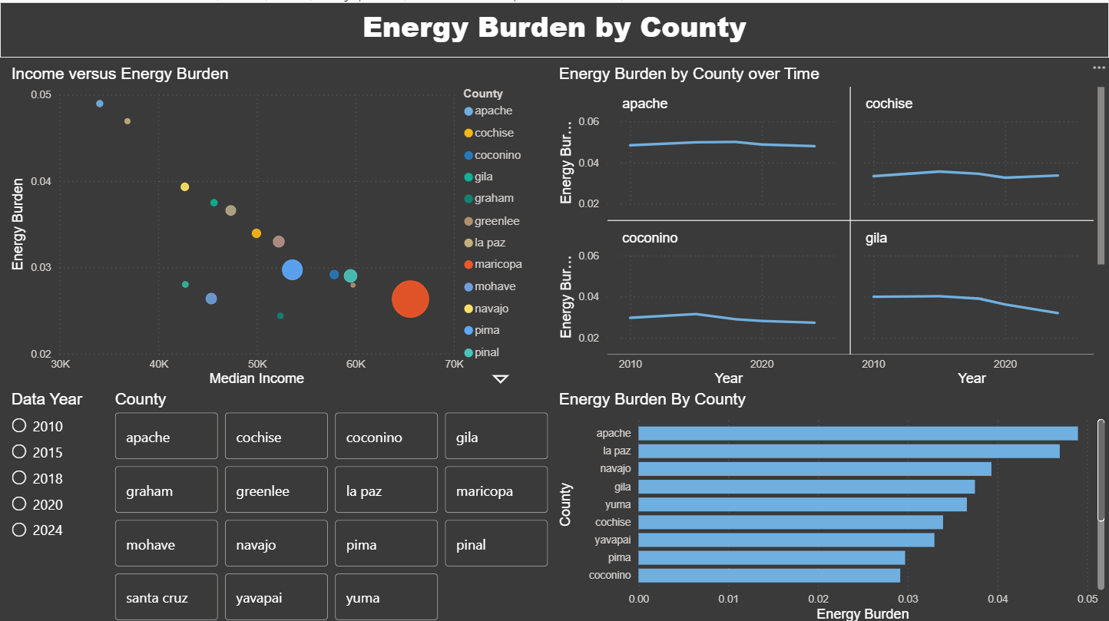
Note: This figure includes a scatter plot, a line chart utilizing small multiples, and a bar chart to analyze graphic variations in energy burden.
This page addresses the research question: How does energy burden vary across counties, and what factors contribute to these differences?
- H₀: Energy burden is consistent across counties.
- H₁: Energy burden varies across counties.
A scatter plot was used to examine the relationship between median income and energy burden at the county level. This is the most appropriate visualization for identifying correlations between two continuous variables. Compared to line charts, the scatter plot avoids implying continuity and instead highlights distribution and clustering.
The visualization includes:
- X-axis: Median Income
- Y-axis: Energy Burden
- Legend: County
The scatter plot reveals a negative correlation, where counties with lower median incomes tend to experience higher energy burdens. This provides visual support for rejecting the null hypothesis.
Small multiples were used to display energy burden trends for individual counties over time. This design is superior to a single multi-line chart because it reduces clutter and allows for clearer comparison across regions (Microsoft Corporation, 2023).
A bar chart ranks counties by average energy burden, highlighting disparities. Counties such as Apache and La Paz appear to have consistently higher energy burdens, indicating structural differences in economic conditions or energy costs.
Interactivity is enhanced through slicers for data year and county, allowing users to isolate specific subsets of data and observe how patterns change across dimensions.

Modeling And Risk Factors
Figure 5
Modeling and Risk Factors Dashboard
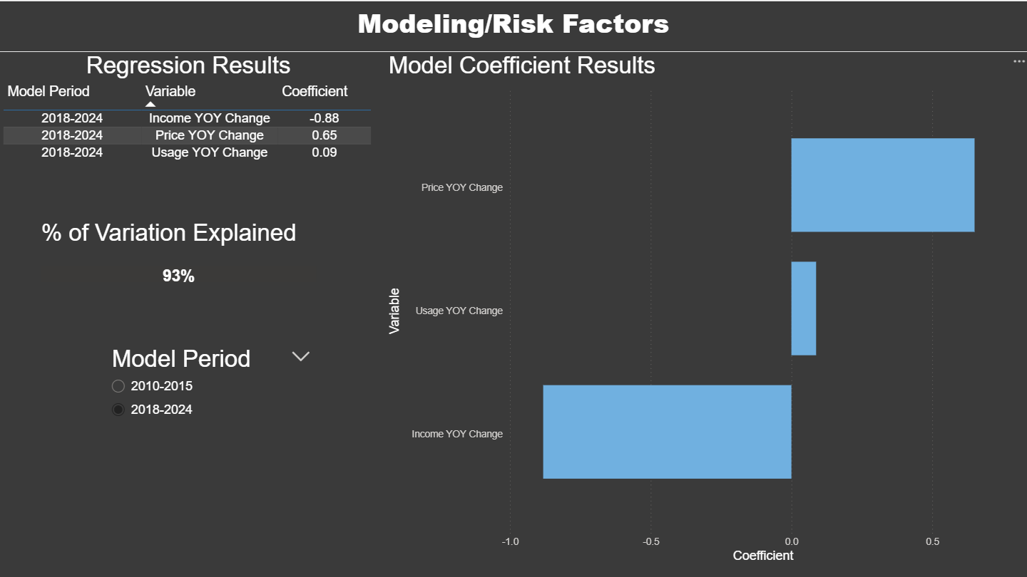
Note: This figure displays regression coefficients and model explanatory power for energy burden.
This page addresses the research question: what factors most strongly influence energy burden?
The regression model evaluates the relationship between energy burden and key predictors, including income change, price change, and usage change.
The results show:
- Income YOY Change: Negative coefficient (~ -0.88 )
- Price YOY Change: Positive coefficient (~ 0.65)
- Usage YOY Change: Small positive effect
The model explains approximately 93% of variation in energy burden, indicating strong explanatory power.
A horizontal bar chart was used to display coefficients because it allows for easy comparison of magnitude and direction. Compared to tables alone, this visualization improves interoperability and highlights the relative importance of each variable.
These results indicate that:
- Increasing income reduces energy burden
- Rising energy prices significantly increased energy burden
- Usage has a smaller but still positive effect
This provides strong statistical support for rejecting the null hypothesis and confirms the economic and pricing factors are key drivers of energy burden.

Dashboard Design and User Experience
The dashboard is designed using a top to bottom and left to right visual hierarchy, aligning with natural reading patterns. KPI cards are positioned at the top or left to provide context, followed by detailed analytical visuals.
Color is used consistently to represent variables across pages, improving user comprehension and reducing cognitive load. Titles and labels are clearly defined to enhance accessibility and ensure readability on both desktop and mobile layouts.
Interactivity is a key component of the design. Slicers for county and year allow users to dynamically filter data, enabling customized analysis. This interactivity transforms the dashboard from static report into an exploratory analytical tool.

Chapter 5: Conclusions and Implications

Summary Of Hypothesis and Results
This study examined the relationship between income, energy costs, and energy burden across Arizona counties over multiple time periods (2010, 2015, 2018, 2020, and 2024). The analysis integrated data from the U.S. Energy Information Administration (EIA), U.S. Census Bureau, and the utility service area data from Arizona Public Service.

Hypothesis One
H₀ (Null): Median household income has no significant relationship with energy burden.
H₁ (Alternative): Median household income has a significant inverse relationship with energy burden.
Results: Null hypothesis rejected.
Explanation:
Regression modeling demonstrated a consistent negative relationship between median income and energy burden across all years analyzed. Counties with higher median incomes exhibited lower energy burden, indicating that energy cost represents a smaller portion of total income. This finding aligns with national patterns showing that lower-income households spend a higher share of income on energy (U.S. Census Bureau, 2024)

Hypothesis Two
H₀: Energy cost variables do not significantly influence energy burden.
H₁: Energy cost variables significantly influence energy burden.
Result: Null hypothesis rejected.
Explanation:
Energy pricing variables, including cost per customer and price per kilowatt-hour, were statistically significant predictors in regression models. Higher electricity costs were associated with increased energy burden, particularly in lower-income counties. These findings are consistent with EIA data indicating that electricity pricing directly impacts household expenditure (U.S. Energy Information Administration, n.d.).

Hypothesis Three
H₀: Energy consumption does not significantly affect energy burden.
H₁: Energy consumption significantly affects energy burden.
Result: Partially rejected.
Explanation:
Energy consumption showed inconsistent significance across models. While higher usage contributed to increased burden in some cases, the relationship was not stable across all years. This suggests that consumption alone is not a primary driver; instead, its effect is mediated by income and pricing variables.

Hypothesis Four
H₀: There are no significant differences in energy burden across counties over time.
H₁: Energy burden varies across counties and over time.
Result: Null hypothesis rejected.
Explanation:
Analysis revealed clear geographic and temporal variation. Counties with lower income levels and differing utility structures showed consistently higher energy burdens. Utility service coverage and infrastructure differences, as reflected in APS service area data, contribute to these disparities (Arizona Public Service, n.d.).

Project Summary and Reflection

Project Summary
This project analyzed energy burden across Arizona counties by integrating data sets from the U.S. Census Bureau, EIA, and APS. Data preparation required extensive cleaning, transformation, and normalization due to inconsistencies in formatting and structure across years.
Key processes included:
- Standardizing census income and housing data (U.S. Census Bureau, 2010; 2024)
- Aggregating EIA utility-level data into county-level metrics (U.S. Energy Information Administration, n.d.)
- Mapping utilities to counties using APS service area reference (Arizona Public Service, n.d.)
- Calculating derived variables such as energy burden and price per kWh

Key Findings
- Income is the strongest predictor of energy burden
- Energy pricing significantly affects affordability, particularly in lower-income counties
- Consumption alone is not a reliable predictor
- Geographic disparities persist across counties
- Structural and economic factors jointly influence energy burdens

Major Challenges Encountered
The project involves several key challenges:
- Data inconsistency: Variations across census and EIA data sets require multiple transformation strategies
- Utility mapping complexity: Utilities serving multiple counties required custom allocation methods
- Housing data variation: Structural differences between datasets necessitate re-binning approaches
- Workflow management: Maintaining consistency across multiple datasets and time periods

Lessons Learned
- Data preparation is the most critical phase of analysis
- Real world data requires iterative cleaning and validation
- Modular workflows improve reproducibility
- Statistical findings must be interpreted within context
- Visualization enhances communication of complex results

Professional and Personal Development
This project strengthens skills in:
- Data cleaning and transformation
- Regression modeling and statistical analysis
- Data integration for multiple sources
- Dashboard development using Power BI
- Communicating insights to diverse audiences
These skills directly support future work and data analytics and operation focused roles.

Real World Implications

Energy Burden as a Societal Issue
Energy burden represents a critical challenge affecting millions of households. High energy costs relative to income can lead to financial instability and reduce access to essential services such as healthcare, housing, and utilities (Drehobl & Ross, 2016).

Income Disparities
The analysis confirms that lower-income households experience significantly higher energy burdens. This reflects broader structural inequality in a cost-of-living distribution.
Implications:
Targeted financial assistance and wage growth policies can reduce disparities in energy affordability.

Public Policy and Utility Regulation
Utility pricing structures play a direct role in shaping energy burden.
Implications:
Policymakers can use these findings to:
- Evaluate rate structures
- Implement tiered pricing systems
- Expand assistance programs

Health Care Impact
Energy insecurity is linked to negative health outcomes, as households may reduce heating or cooling to save costs (Hernández, 2016).
Implication:
Improving energy affordability supports both physical and mental health outcomes.

Housing And Infrastructure
Energy burden is closely tied to housing efficiency and infrastructure quality.
Implications:
Investments in energy-efficient housing can reduce long-term costs and improve sustainability.

Environmental And Sustainability Considerations
Understanding energy usage patterns can inform sustainability initiatives.
Implication:
Reducing consumption through efficiency programs lowers both financial burden and environmental impact.

Application To Future Data Analytics Work
This project demonstrates the value of data analytics in addressing real-world challenges. Future work could include:
- Predictive modeling using machine learning
- Expansion to national level data sets
- Integration of climate and weather variables

Conclusion
This study demonstrated that income and energy costs are the primary drivers of energy burden across Arizona counties. The findings highlight significant disparities and provide insight into how economic and structural factors influence affordability.
Beyond technical outcomes, this project emphasized the importance of data preparation, analytical rigor, and clear communication. It also reinforced the role of data analytics in supporting informed decision-making and addressing complex societal challenges.

References
Arizona Public Service. (n.d.). Service area maps. Retrieved from APS: https://www.aps.com/en/Residential/Service-Plans/Service-Area-Maps
Drehobl, A., & Ross, L. (2016). Lifting the high energy burden in America's largest cities: How energy efficiency can improve low-income and underserved communities. American Council for an Energy-Efficient Economy.
Hernández, D. (2016). Understanding energy insecurity and why it matters to health. Social Science & Medicine, 167, pp. 1-10. Retrieved from Social Science & Medicine, 167: https://doi.org/10.1016/j.socscimed.2016.08.029
Microsoft Corporation. (2023). Create small multiples in Power BI. Retrieved from Microsoft Learn: https://learn.microsoft.com/en-us/power-bi/visuals/power-bi-visualization-small-multiples
PolicyMap. (n.d.). PolicyMap . Retrieved from PolicyMap: https://www-policymap-com.ezp.mesacc.edu/newmaps/e/mesacc
U.S. Bureau of Labor Statistics. (n.d.). Consumer Price Index supplemental files. Retrieved from U.S. Bureau of Labor Statistics: https://www.bls.gov/cpi/tables/supplemental-files/
U.S. Census Bureau. (2024). Median household income in the past 12 months (S1903). Retrieved from U.S. Census Bureau: https://data.census.gov/table/ACSST5Y2024.S1903
U.S. Census Bureau. (2024). Selected housing characteristics: Electricity and income (ACS 1-year estimates). Retrieved from U.S. Census Bureau: https://data.census.gov
U.S. Energy Information Administration. (n.d.). Electricity data. Retrieved from U.S. Energy Inforamtion Administration: https://www.eia.gov/electricity/data.php

